ЛАБОРАТОРНА РОБОТА №9

ТЕМА: ПРИВ’ЯЗКА ДО КОЛЕКЦІЙ ТА ШАБЛОНИ ДАНИХ

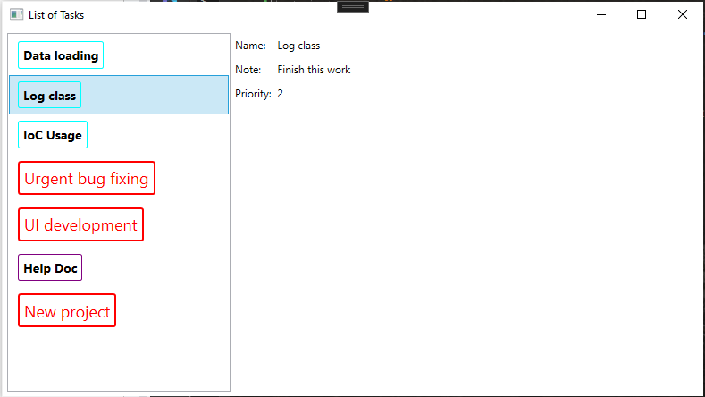

| MainWindow.xaml |
| --- |
| <Window x:Class="WpfApp8.MainWindow"  xmlns="http://schemas.microsoft.com/winfx/2006/xaml/presentation"  xmlns:x="http://schemas.microsoft.com/winfx/2006/xaml"  xmlns:d="http://schemas.microsoft.com/expression/blend/2008"  xmlns:mc="http://schemas.openxmlformats.org/markup-compatibility/2006"  xmlns:local="clr-namespace:WpfApp8"  xmlns:WpfApp8="clr-namespace:WpfApp8"  mc:Ignorable="d"  Title="List of Tasks" Height="450" Width="800">  <Window.Resources>  <DataTemplate DataType="{x:Type WpfApp8:kuma}">  <Border Name="brd" BorderBrush="Aqua" BorderThickness="1" CornerRadius="2"  Padding="5" Margin="5">  <TextBlock FontSize="14" FontWeight="Bold" Text="{Binding Name}"/>  </Border>  <DataTemplate.Triggers>  <DataTrigger Binding="{Binding Path=Type}" Value="Support">  <Setter TargetName="brd" Property="BorderBrush" Value="Purple"/>  </DataTrigger>  </DataTemplate.Triggers>  </DataTemplate>  <DataTemplate x:Key="importantTask">  <Border BorderBrush="Red" BorderThickness="2" CornerRadius="2" Padding="5" Margin="5">  <TextBlock FontSize="18" Foreground="Red" Text="{Binding Name}"/>  </Border>  </DataTemplate>  <local:TaskTemplateSelector x:Key="selector" />  </Window.Resources>  <StackPanel Margin="5" Orientation="Horizontal">  <ListBox Name="IstTasks" HorizontalAlignment="Stretch" Width="250" ItemTemplateSelector="{StaticResource selector}"/>  <Grid Margin="5" DataContext="{Binding ElementName=IstTasks, Path=SelectedItem}">  <Grid.ColumnDefinitions>  <ColumnDefinition Width="Auto"/>  <ColumnDefinition Width="7"/>  <ColumnDefinition Width="200"/>  </Grid.ColumnDefinitions>  <Grid.RowDefinitions>  <RowDefinition Height="Auto"/>  <RowDefinition Height="11"/>  <RowDefinition Height="Auto"/>  <RowDefinition Height="11"/>  <RowDefinition Height="Auto"/>  </Grid.RowDefinitions>  <TextBlock Grid.Row="0" Grid.Column="0" Text="Name:"/>  <TextBlock Grid.Row="0" Grid.Column="2" Text="{Binding Name}"/>  <TextBlock Grid.Row="2" Grid.Column="0" Text="Note:"/>  <TextBlock Grid.Row="2" Grid.Column="2" Text="{Binding Note}"/>  <TextBlock Grid.Row="4" Grid.Column="0" Text="Priority:"/>  <TextBlock Grid.Row="4" Grid.Column="2" Text="{Binding Priority}"/>  </Grid>  </StackPanel>  </Window> |

| MainWindow.xaml.cs |
| --- |
| using System;  using System.Collections.Generic;  using System.Collections.ObjectModel;  using System.Linq;  using System.Security.AccessControl;  using System.Text;  using System.Threading.Tasks;  using System.Windows;  using System.Windows.Controls;  using System.Windows.Data;  using System.Windows.Documents;  using System.Windows.Input;  using System.Windows.Media;  using System.Windows.Media.Imaging;  using System.Windows.Navigation;  using System.Windows.Shapes;  namespace WpfApp8  {  /// <summary>  /// Логика взаимодействия для MainWindow.xaml  /// </summary>  public partial class MainWindow : Window  {  private readonly ObservableCollection<kuma> kumas;  public MainWindow()  {  InitializeComponent();  kumas = new ObservableCollection<kuma>(new kumas());  IstTasks.ItemsSource = kumas;  }  }    } |

| kuma.cs |
| --- |
| using System;  using System.Collections.Generic;  using System.Linq;  using System.Text;  using System.Threading.Tasks;  using System.Windows;  using System.Windows.Controls;  namespace WpfApp8  {  public class kuma  {  public string Name { get; set; }  public string Note { get; set; }  public int Priority { get; set; }  public kumaType Type { get; set; }  }  public enum kumaType { Coding, Testing, Support }  public class kumas : List<kuma>  {  public kumas()  {  Add(new kuma { Name = "Data loading", Note = "Необхідна тестова робота з БД", Priority = 2, Type = kumaType.Testing });  Add(new kuma { Name = "Log class", Note = "Finish this work", Priority = 2, Type = kumaType.Coding });  Add(new kuma { Name = "IoC Usage", Note = "Find more info", Priority = 4, Type = kumaType.Coding });  Add(new kuma { Name = "Urgent bug fixing", Note = "Problem with class C", Priority = 1, Type = kumaType.Support });  Add(new kuma { Name = "UI development", Note = "Make markup for Main Window", Priority = 1, Type = kumaType.Coding });  Add(new kuma { Name = "Help Doc", Note = "Write technocak documentation", Priority = 3, Type = kumaType.Support });  Add(new kuma { Name = "New project", Note = "Plan the meeting", Priority = 1, Type = kumaType.Support });  }  }  public class TaskTemplateSelector : DataTemplateSelector  {  public override DataTemplate SelectTemplate(object item, DependencyObject container)  {  if (item is kuma task)  {  Window window = Application.Current.MainWindow;  if (task.Priority == 1)  {  return window.FindResource("importantTask") as DataTemplate;  }  else  {  DataTemplateKey templateKey = new DataTemplateKey(typeof(kuma));  return window.FindResource(templateKey) as DataTemplate;  }  }  return null;  }  }  } |